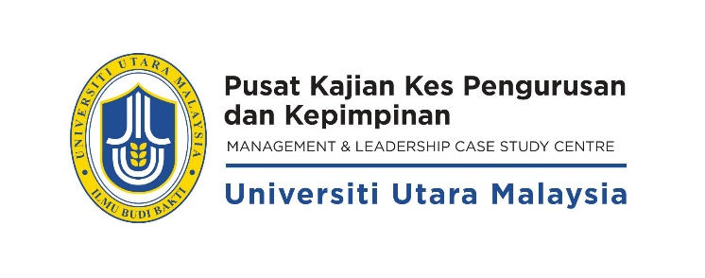

**CASE RELEASE FORM**

I have examined the material entitled ___________________________________________________________________

_________________________________________________________________________________________________

submitted by ______________________________________________________________________________________

On behalf of myself and/or the organization named below, I hereby authorize the Pusat Kajian Kes Pengurusan dan Kepimpinan (PKKPK), Universiti Utara Malaysia, as well as any individuals or organizations authorized by PKKPK to use this material at Universiti Utara Malaysia and elsewhere, and to adapt, reproduce and distribute it in any manner or medium, including commercially published case books and to translate to other foreign languages.

Company’s stamp:

Signature : ________________________________

Name : ________________________________

Position : ________________________________

Organization : ________________________________

Address : ________________________________

________________________________

Date : ________________________________